OUTPUT FOR LAB ASSIGNMENT

1)Login page

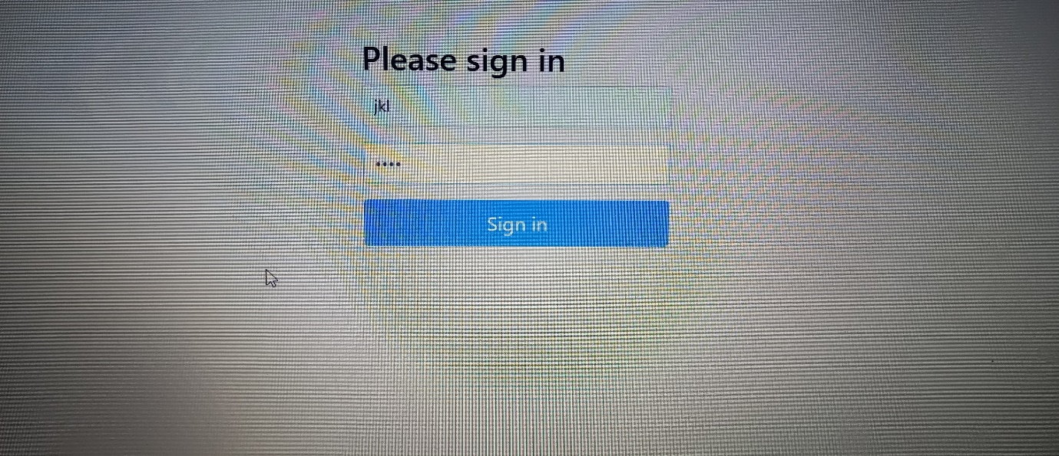

Localhost:9099/StudentManagement/login page opens

Username:jkl

Password:1111

2)Students Directory page

3)For adding a new student

4)After adding the information of students

5)Updating the department of student Aruna

6)After updating the details

8)Final output page

9)output in mysql

